Assignment 8 Logistic Regression by Joshua Troup

1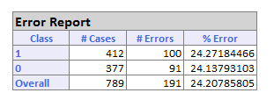

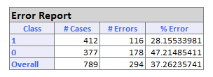

2

Diagram 1 shows the validation data error report on the full model. Diagram 2 shows the validation data error report on the data excluding price. The overall % error is much greater in the model excluding price compared to the full model.



The coefficient for “close price” is 0.1047. This positive coefficient means that higher closing prices are associated with a higher probability of the auction being competitive.

Looking at the odds coefficient (1.11), we see that every $1 increase in the closing price increases the odds of the auction being competitive by a factor of 1.11.

In our case the significance level = 0.1 > pvalue = 0.

Therefore, we reject the above null hypothesis.